Publish Cancel-Replace To PAR

Overview

Current processing
Currently all Cancel-Replace messages being handled by PAR Adapter (via Par Server) using synchronous CORBA call.

New requirement
- All outbound Cancel-Replace messages from OHS to PAR will be publish to event channel (OrderRouting Channel) and PAR client/workstation pick up these messages from channel.

The outbound Cancel-Replace messages from OHS (CBOEdirect Server) to PAR will be through asynchronous communication, OHS will publish the message to event channel/queue and PAR will pick it up. Also these messages will be persisted in database table on OHS side before publish and mark this message as not processed and PAR will acknowledge this message to mark the processed flag as processed once it receives it.

Assumption
- Simple and Complex Orders/requests will use the same mechanism.
For detail please refer to Requirement document.

Implementation
The existing classes will be used for this functionality are:
- RoutedMessageHomeImpl – Home will Find or Create the Routes Message for persistence.
- RoutedMessageImpl – The message (domain object) that will be persisted for each out going Cancel-Replace message with processed flag and other attributes e.g. Message Type, Location, Location Type, Order DB Id etc.
- WFStepRouteCancelReplaceReq – Modified this class to only mark the location or destination on context and use common step for publish or send.
There will be new class implemented as part for Send/Publish message to PAR functionality:
- WFStepPublishToPAR – This will be used for sending Cancel-Replace, Manual Cancel-Replace and Replacement Order to PAR using publish.
- ManualCancelReplaceStruct – New struct that contains ManualCancelRequestStruct, OrderManualHandlingStruct, array of QuoteQueryV3Struct, and RouteReasonStruct.

When the Cancel-Replace request executes the step WFStepRouteCancelReplaceReq that will mark the desired destination on CancelReplaceContext and forward it to WFStepPublishToPAR which in-turns will use generalize WFStepPublishToAbstractPAR to actually create ManualCancelReplaceStruct, save the location, adjust the cancel quantity, create the RoutedMessage , increment PAR pending cancel quantity, publish the request to “OrderRouting” Event Channel and create the Histories.

Scripts
- None

Database
- None

SetContext

XML/DTD
Modified following workflows XML to use publish for Cancel-Replace request:
- CancelReplaceCMI_new_Workflow.xml
- CancelReplaceReturnChaseOrder_Workflow.xml

Homes/Services
- RoutedMessageImpl
- RoutedMessageHomeImpl

ImplPlan
- Sequence Diagram
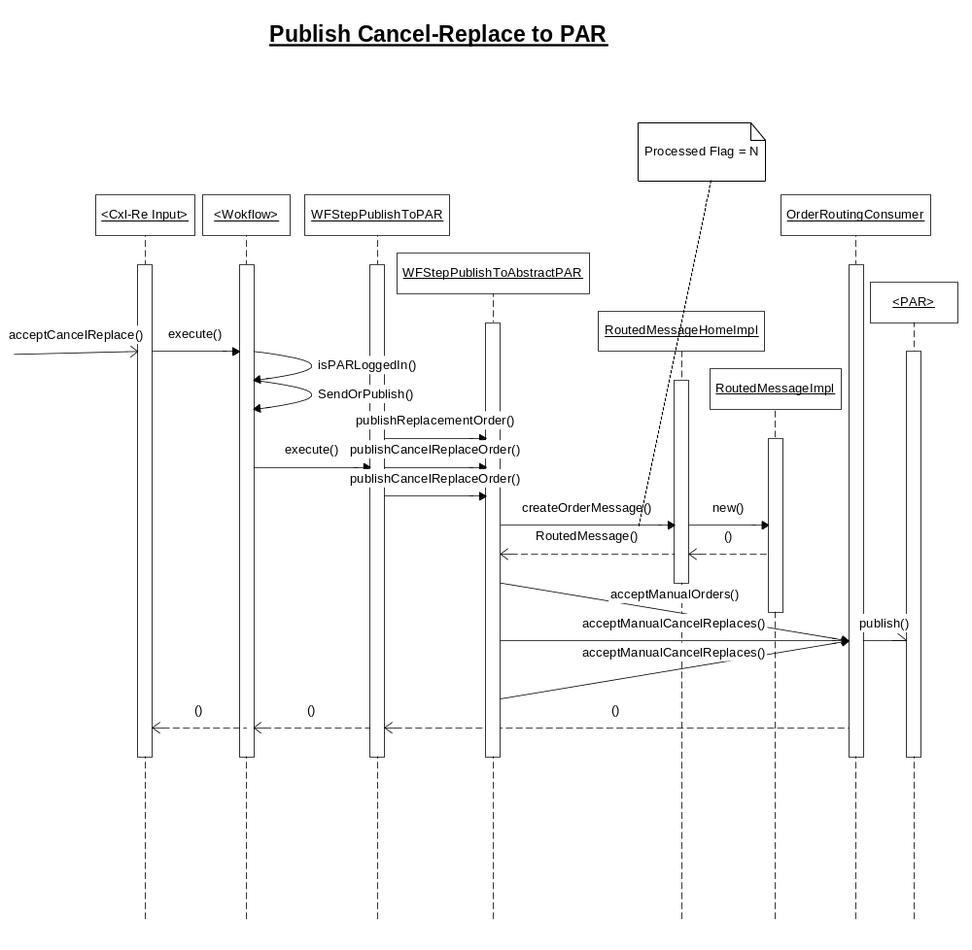

- Class Diagram
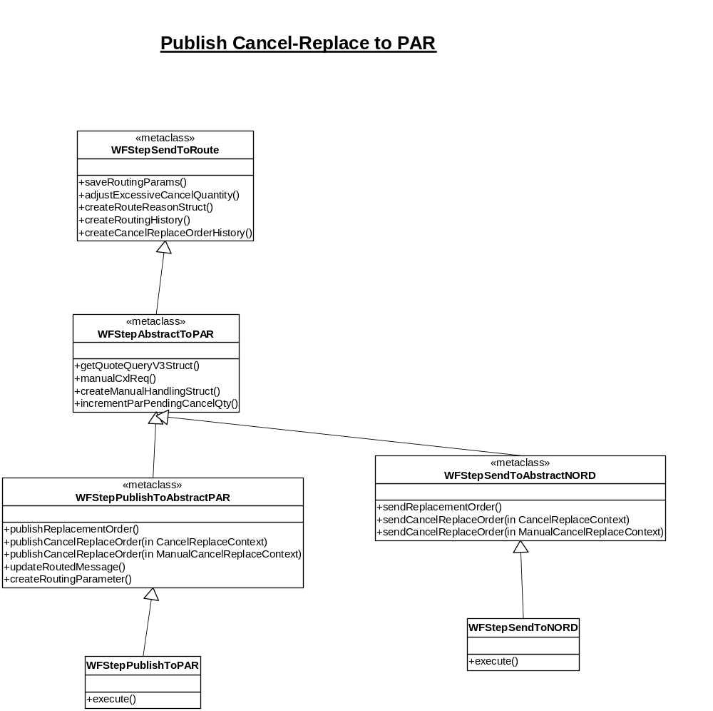

PerformanceTestingProcedure
- .

TestingProcedure

OperatorProcedure
- .

Fallback/Failover

